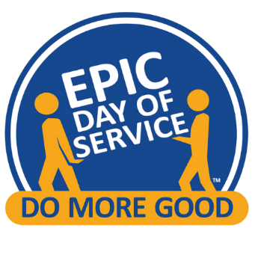
for Communities Worldwide • organized by Rotary Clubs
The Epic Day of Service: A Simple and Effective Fundraising Opportunity
The Epic Day of Service is not only a celebration of service but also a unique opportunity for Rotary Clubs to raise funds. Whether your club is supporting ongoing service projects or launching a major annual fundraiser, the Epic Day provides flexible and effective tools to help your club achieve its goals. Here’s how easy it is to incorporate fundraising into your Epic Day plans.

Flexible Fundraising Options
When your Rotary Club participates in the Epic Day of Service, you gain access to a dedicated website with tools designed to simplify fundraising. The platform supports four primary fundraising avenues:
- From Members
- From Friends and Family
- From Sponsors
- From Your Epic Day Project

How It Works
Funds from Rotary Club Members
Promoting your Epic Day activity begins in the winter and continues through the spring. Frequent announcements, emails, and notices on ClubRunner will keep your members informed and excited. In addition to encouraging participation, you can:
- Invite members to donate directly to your club’s charitable arm when they sign up for the project on the Epic Day website.
- Set up a matching fund. Generous Rotarians can create a matching account, doubling the impact of each donation.
This tool is a simple way to allow members to support the Epic Day and other club initiatives without the need for a separate fundraiser.

Funds from Friends of Rotarians
The Epic Day website makes it effortless for members to involve their personal networks. Each member who registers for your club’s service project automatically receives a personalized fundraising page. Here’s how it works:
- The page includes a pre-written email that members can send to friends and family, or they can customize it to suit their style.
- The platform tracks individual fundraising totals and distributes funds directly to the club after the Epic Day.
There’s no need for committees or auction item solicitations. Members simply share their page, and donations flow directly to your club, with minimal effort.
Key Benefits:
- 90% of the funds raised go directly to your club, with only minor deductions for processing and shared operating expenses (up to 5%).

Funds from Sponsors
The Epic Day is an excellent opportunity to engage local businesses:
- Identify companies whose goals align with your service project.
- Offer sponsorship opportunities in exchange for including their branding on your club’s Epic Day materials.
- Leverage existing connections within your membership to approach potential sponsors.
This approach not only raises funds but also strengthens community partnerships.

Funds from the Service Project Itself
Some clubs have successfully raised funds directly at their service project:
- For example, a club collecting recycling materials during the Epic Day asked visitors for donations, raising $13,000.
- Consider creative ways to engage the public and encourage on-the-spot contributions.

Real Success Stories
Many clubs have already demonstrated how impactful the Epic Day can be:
- One Rotary Club raised $95,000 through their Epic Day activities in 2024.
- Other clubs have incorporated the Epic Day as their primary annual fundraiser while continuing to support additional service projects throughout the year.

Key Date and Final Notes
The next Epic Day of Service will take place on May 17, 2025. By participating, your club joins a global movement of Rotary Clubs united in service. With the built-in fundraising tools, you can enhance your impact and support even more service initiatives.
Important: For 2025, the Epic Day fundraising platform can only collect and distribute funds to clubs with access to a 501(c)(3) foundation. We aim to expand this capability in future years.
Let’s make the Epic Day of Service a transformative experience for your club and community. Get started today and see how easy it is to make a difference!

